The literature landscape on 1.5°C Climate Change and Cities

*William Lamb1, Max Callaghan1, Felix Creutzig1,2, Radhika Khosla3, Jan Minx1,4*

*Affiliations*

*1 Mercator Research Institute on Global Commons and Climate Change, Torgauer Str. 14, 10829 Berlin, Germany*

*2 Sustainability Economics of Human Settlements, Technical University Berlin, Str. des 17. Juni 135, 10623 Berlin, Germany*

*3 Centre for Policy Research, New Delhi 110021, India*

*4 Hertie School of Governance, Friedrichstr. 189, 10117 Berlin, Germany*

*\* Corresponding author: [lamb@mcc-berlin.net](mailto:lamb@mcc-berlin.net)*

*Abstract. Cities are key for implementing ambitious climate goals such as the 1.5°C target of the Paris Agreement. But in times of an exponentially growing literature, the appropriate selection of the urban research for assessments is no longer obvious. Employing methods from computational linguistics, we gain a systematic overview of transport, urban form, buildings, and waste management – each of which play important time-sensitive roles for meeting the 1.5°C target in cities. The epistemic core of this urban mitigation literature is currently focused on urban form, despite extensive research into demand-side options such as congestion charging, parking prices, active travel provisioning, building construction height, and behavioral aspects of energy use. To achieve 1.5°C, all such city-scale options need to be examined.*

# Introduction

To inform the global stock-take of the Paris Agreement, the Intergovernmental Panel on Climate Change (IPCC) has been tasked with a Special Report (SR) to comprehensively assess the state of scientific knowledge on the 1.5°C temperature goal. The discussion on the 1.5°C goal so far has emphasized the role of negative emissions, as well as the higher economic costs for staying within tight and fast dwindling emission budgets [1–4]. The debate has largely neglected that 1.5°C policy pathways also come with a distinctively different (gross) CO2 emissions profile compared to 2°C; namely even deeper emissions reductions in the medium-run and long-run, as shown in Figure 1. Cities have a self-evident role in reaching this goal: to leverage their position as the locus of human activity in order to put in place low-carbon infrastructures globally [5].

Cities as infrastructure hotspots are critical for shaping long-run emission trajectories, providing both opportunities for leapfrogging, and risks for emissions lock-in [5–8]. In the wake of slow national progress in climate action, they have emerged as one of the more ambitious policy communities in global climate change governance, despite real problems in assessing their actual performance to date [9]. Nevertheless, cities and local governments with their direct leverage over significant emission components are increasingly recognized as important building blocks for organizing ambitious climate policies in a multi-level governance system [8,10,11]. The inclusion of cities as a mitigation response topic in the SR [12] is an important step towards understanding their potential role in climate policy.

The assessment of an urban mitigation literature, however, faces two fundamental challenges: first, like in other fields of climate change research, the body of relevant literature is large and fast-growing. Minx et al. [17] estimate that the quantity of new peer-reviewed research (as recorded by the ISI Web of Science) published during the sixth assessment cycle is roughly equal to the size of the entire climate change literature before AR6. This trend renders the task of tracking scientific progress increasingly impossible for individuals to manage, even in highly specialized fields, risking bias and systematic omissions in the selection of literature for assessments. Second, despite recent progress [18], urban climate change assessments are still in their infancy. The available literature has not yet been aggregated into discrete bodies of knowledge that can be easily drawn upon, further risking their exclusion in an already overwhelming field of climate research. Not least, we still lack a basic understanding of the urban contribution to global emissions and the drivers thereof [11,19–21].

To enable a more transparent assessment of the role of cities in climate change mitigation, and to advance discussions in urban climate change research, the relevant literature base needs to be characterized to answer key questions: What are the core topic areas in the literature that emphasize urban climate change mitigation? What are the epistemic communities that drive this growing urban literature? How is the literature organized in terms of key objectives and policies for the short, medium and long-term?

As a first step towards addressing these issues, this paper systematically identifies the relevant literature on cities and climate change, and analyzes the state and evolution of the research field in terms of its thematic structure as a corner stone for the upcoming special report on the 1.5°C goal. We build a reproducible search query based on our understanding of the urban literature, focusing on urban mitigation measures and policies related to transport, buildings, waste, and urban form. We use automated content analysis to endogenously define the thematic structure of the literature identified, and bibliometric analysis to identify epistemic communities in the field. Using these scientometric methods we also examine the IPCC 5th Assessment (AR5) Working Group III (WGIII) report in terms of its coverage of urban mitigation issues, highlighting gaps that should be filled in the upcoming SR.

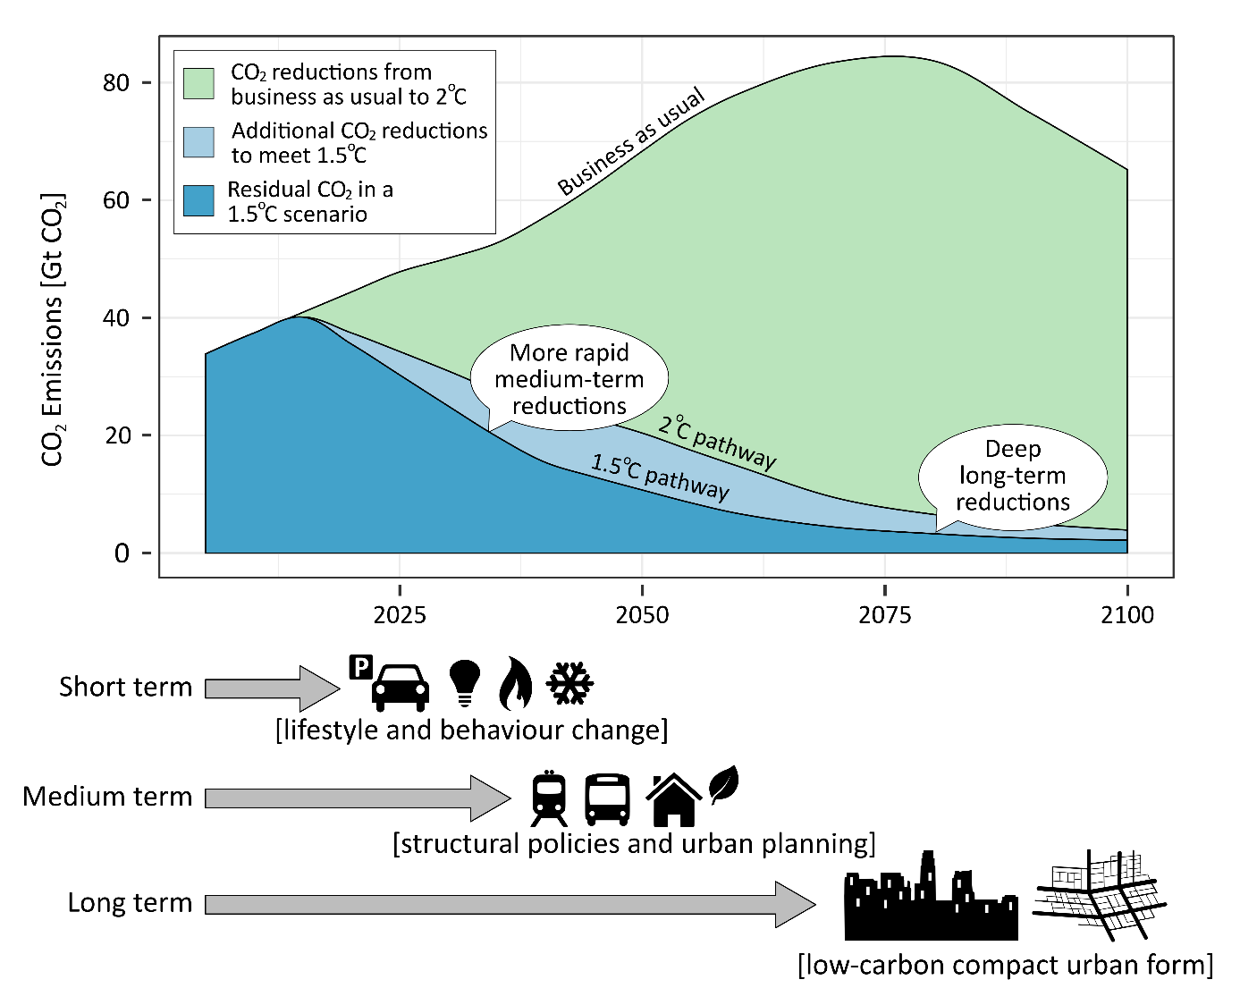

**Figure 1: Initiating an immediate structural shift towards low-carbon urban infrastructure is key for achieving 1.5°C, as compatible pathways are characterized by more rapid CO2 emission reductions and an even lower residual CO2 emissions than 2°C.** Depicted are gross emissions pathways for two REMIND scenarios with full technological availability and emission reductions starting in 2020 [1]. The 1.5°C scenario has a probability of not exceeding 1.5°C in 2100 of 0.74 and a probability of not exceeding 1.5°C throughout the century of 0.48. The corresponding probabilities for 2°C scenarios were 0.83 and 0.8. Not shown are the negative emissions required to stay within the relevant CO2 emission budgets and meet these targets: which total 146 Gt for the 1.5°C scenario and 124 Gt for the 2°C scenario. Note that this graph does not consider the relevant non-CO2 greenhouse gases and their development over time.

# Methods

## Delineating the urban mitigation literature

Arguably, an urban mitigation assessment should focus on the demand-side of energy consumption and its associated climate impact. Although supply-side activities such as power generation and industry also take place within cities, they are well captured by other research communities (in particular, integrated assessment modelling). By contrast, the demand-side of climate change mitigation has received less attention in climate assessments (but see [23]). The demand-side is a natural point of focus for an assessment of urban systems: not only are the everyday practices and uses of energy highly influenced by the shape, structure and organization of cities [24–26], but the majority of energy consumption in the 21st century is projected to take place within them [9,11,27,28].

Four key domains of literature can shed light on the urban drivers of greenhouse gas emissions, and opportunities for their mitigation: transportation, buildings, waste management, and urban form (Figure 2). Urban form captures aspects of both transport and buildings but is distinct in addressing layout and wider systemic effect at larger spatial scales. In the context of the 1.5°C target, these domains play varied roles along different timescales (Figure 2). Understanding these time scales is crucial for advancing urban contributions towards net zero emission trajectories.

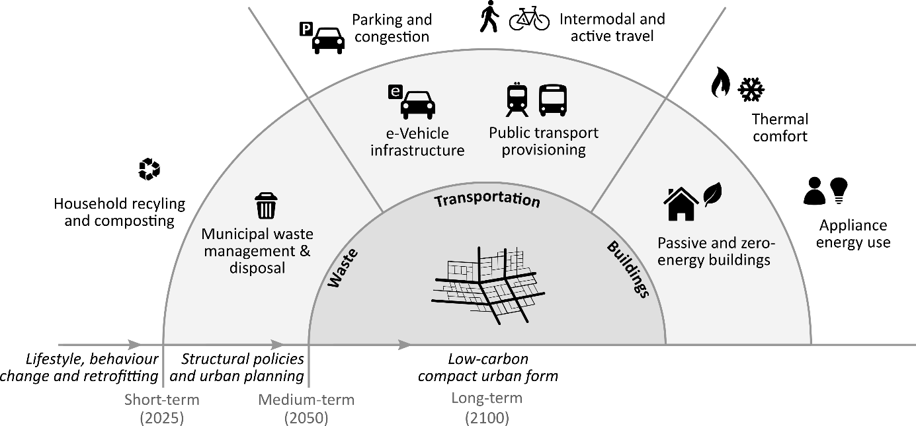

**Figure 2: Scope of the urban mitigation literature assessed, including measures that address urban transport, buildings, waste, and urban form.** Note that neither supply-side energy and material production, nor a broader set of provisioning infrastructures and services (e.g. healthcare access, green spaces) are included within the scope. The rationale for this is that the former is assessed in other mitigation communities, and the latter is more appropriate for an assessment of sustainability, rather than climate change mitigation.

In the short-term, lifestyle and behavioral options can contribute most to climate change mitigation. This involves changes in preferences, habits, and decision-making, such as telecommuting, adapting to different room temperatures, food waste reduction, and so forth. These have been reviewed in literatures on the urban transport sector [14,26,29–31], the building sector [32–35], food waste [36], and the overall demand-side [23].

The middle and long-term is dominated by capital and infrastructure stocks [37]. Many options are situated in the buildings sector, including more efficient consumer appliances, heating and cooling systems, and building envelope design and materials. However, they must be fostered now to achieve notable results in 5-10 years. Similarly, the long life-time of road and rail-based systems (40-75+ years) means that the transition towards sustainable transport systems must be implemented now to enable deep decarbonization pathways within 20-40 years.

With the efficient use of buildings and city space, underpinned by active travel and public transportation, important network externalities emerge, driving cities towards low-carbon compact urban forms towards the end of this century. Both empirical and analytical urban economic literature emphasize the role of fuel prices in shaping urban form and the balance of different transport systems [16,38,39].

## Literature search, topic modelling and scientometric analysis

To identify the urban mitigation literature covered by these four domains, we develop a structured search query for the Web of Science (WOS) literature database. This includes specific combinations of keywords for each domain (e.g. “bicycle infrastructure provisioning”), as well as more generic strings (“low-carbon transport”). We attempt to identify studies primarily focused on climate change mitigation, as well as those that are relevant but might not refer directly to mitigation. The full search methodology is detailed in the Supplementary Materials (SM), as is the resulting list of documents that we obtain. This document set is largely comprised of journal papers, but also includes conference proceedings and book chapters. For each document, we obtain the title, abstract, keywords and list of references.

To quickly digest the major themes of the document set, we perform: (1) an automated content analysis on the document titles, abstracts and keywords; and (2) a scientometric analysis on the document references. For (1) we use non-negative matrix factorization, a method that assumes words systematically co-occur within documents, and that repeated co-occurrences across the document set indicate a shared sematic structure (“topics”). This procedure will generate a list of topics for the entire document set, where each topic is comprised of co-occurring words (e.g. the words “air”, “pollution”, “quality” likely describe a topic focused on local air pollution). Since our search query already specifies the content of research in our document set, this method may appear redundant. However it does offer important advantages: it provides quantitative metrics describing the prevalence of each topic; it allows us to examine the correlations between topics (based on the likelihood that they appear together in documents); and it will discover latent topics alongside those we explicitly searched for.

For (2), we use the reference data from our document set to generate a bibliographic coupling network (two documents are “coupled” if they cite the same third document). The bibliographic coupling network is clustered using a community detection algorithm, identifying groups of documents that tend to cite similar literatures. Combining these results with the automated content analysis, we then describe the topics of research that are prevalent within each cluster, thereby exposing epistemic communities within urban climate change research.

Finally, we have compiled a list of references from the IPCC AR5 WGIII Report, allowing us to examine its direct coverage of the urban literature we identify, and the topics (1) contained in these documents. Refer to the SM for a full description of these methods.

# Results

Our urban mitigation search query identifies a substantial (9,525 publications) and fast growing literature (20.5% per year; see Supplementary Materials Figure 1). The IPCC AR5 has directly cited 129 of these documents. WGIII, specified in our query Moreover, already more than 3500 studies have appeared since AR5 (2014 onwards) and have therefore not been assessed by the IPCC directly or indirectly. Future assessments therefore face a significant task in covering the full breadth of relevant work. In the following sections we present the major themes of the urban literature we identify (the automated content analysis), and the main epistemic communities within the field (scientometric analysis).

## Major themes in urban mitigation research

The automated content analysis identifies 27 topics across the document set (table 1). These include subject areas that were explicitly specified in our search (e.g. “active travel” and “urban form”), as well as latent topics discovered by the analysis (e.g. “network optimization”, “travel behavior”, “air quality”). There are many topics related to transportation research (#2, #9, #10, #12, #14, #16, #20, #21, #22, #24, #25, #27), fewer on buildings (#4, #5, #13, #19, #26), only 3 on waste (#8, #15, #23), a single topic on urban form (#6), while the rest are spread across multiple domains. An example of the latter is the most prevalent topic – “planning & governance” – which reveals a strong policy-focus in the urban literature we have identified.

A range of competing discourses and priorities are apparent across the literature. The documents and keywords highly correlated with building energy standards (#5) show a consistent theme of energy performance assessment in relation to national building standards and codes (such as the LEED certification). Both energy efficiency & consumption (#4) and thermal comfort (#13) capture technical aspects of energy use in buildings (e.g. appliance efficiency), as well as their interface with human behavior (e.g. thermostat preferences). Similarly, within transportation research, congestion charging (#10) is clearly oriented towards traffic management; the public transportation modes (#9, #16) emphasize access and ridership levels; while active travel (#2) remains very much grounded in a public health discourse.

|  |  |  |  |  |
| --- | --- | --- | --- | --- |
| **ID** | **Topic Name** | **Stemmed Keywords** | **Marginal Topic Distribution (%)** | |
| 1 | Planning & governance | develop, sustain, govern, polici, project | | 9.7 |
| 2 | Active travel | activ, health, household, school, walk | | 6.5 |
| 3 | Network optimisation | model, network, optim, propos, problem | | 6.2 |
| 4 | Energy efficiency & consumption | energi, effici, consumpt, save, household | | 6.0 |
| 5 | Building energy standards | build, energi, perform, green, design | | 5.0 |
| 6 | Urban form | urban, citi, land, area, green | | 4.5 |
| 7 | GHG emissions | emiss, carbon, ghg, reduct, gas | | 4.4 |
| 8 | Waste management | wast, manag, solid, landfil, municip | | 4.4 |
| 9 | Public transport | transport, public, car, access, polici | | 4.3 |
| 10 | Congestion charging | price, congest, road, traffic, cost | | 3.8 |
| 11 | System design | system, oper, cost, control, perform | | 3.7 |
| 12 | Travel behaviour | travel, mode, choic, car, time | | 3.4 |
| 13 | Thermal comfort | thermal, comfort, temperatur, indoor, occup | | 3.2 |
| 14 | e-Vehicles | vehicl, electr, fuel, batteri, power | | 3.2 |
| 15 | Waste water | treatment, wastewat, plant, remov, compost | | 3.0 |
| 16 | Rail transit | transit, rail, station, ridership, access | | 3.0 |
| 17 | Air quality | air, pollut, ventil, qualiti, indoor | | 2.9 |
| 18 | Climate change mitigation | climat, chang, mitig, polici, local | | 2.8 |
| 19 | Heating & cooling systems | heat, hous, pump, cool, district | | 2.8 |
| 20 | Transport services & provisioning | servic, ecosystem, oper, public, provid | | 2.7 |
| 21 | Car parking | park, space, car, price, polici | | 2.4 |
| 22 | Bus rapid transit | bus, brt, buse, rout, stop | | 2.3 |
| 23 | Household recycling | recycl, household, collect, materi, program | | 2.3 |
| 24 | Road tolls | toll, lane, road, traffic, congest | | 1.9 |
| 25 | Charging stations | charg, station, congest, ev, scheme | | 1.9 |
| 26 | Building water use | water, suppli, hot, solar, heater | | 1.8 |
| 27 | Cycling | bicycl, cycl, cyclist, pedestrian, lane | | 1.8 |

**Table 1: List of topics and their keywords generated by the automatic content analysis**. Each topic consists of a series of keywords (stemmed to capture multiple word variations), a topic name (assigned by us on manual inspection of keywords and correlated documents), and a marginal topic distribution (describing the percentage of the document set where this topic is found). Topics may be similar in some cases owing to different nomenclature within the same subject area (e.g. congestion charging vs. road tolls).

A useful way to visualize and interpret these results is via a correlation network, showing the propensity for topics to occur together within documents (Figure 3). As expected, the topics on energy, heating and water use in buildings are grouped together. The transportation topics are also densely connected – in particular to network optimization (#3), which describes the modelling, simulation and optimization of traffic flow, and to a lesser extent travel behavior (#12). System design (#11) is a central but more generic topic on the efficient design of building and transport systems.

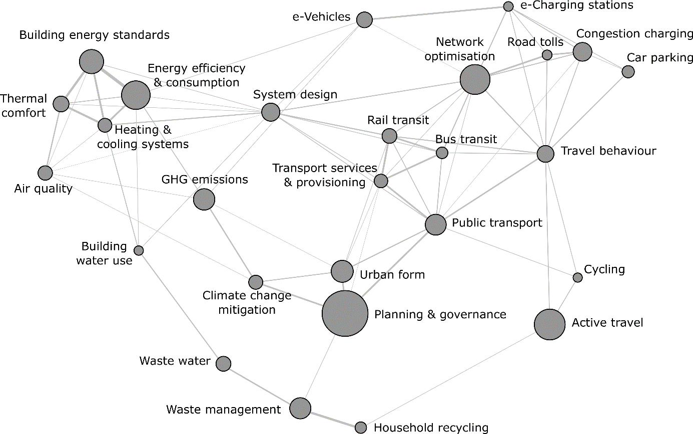

**Figure 3: Correlation structure of urban mitigation topics.** Each node is a topic, scaled by the marginal distribution (see Table 1); each line represents a correlation, based on the co-occurrence of two topics within document abstracts. The highest correlation is 0.3 (between thermal comfort and building energy performance); the lowest is 0.025 (between climate change mitigation and green infrastructure). The visualisation is generated using the force-directed algorithm ForceAtlas2 in Gephi [41].

To what extent is climate change mitigation a prominent discourse in these fields? Table 1 and Figure 3 suggest that it remains rather marginal: papers with climate change mitigation as their main topic tend to focus on macro issues of urban form, GHG (greenhouse gas) emissions accounting in cities, and building interventions (via energy efficiency), but less so on waste management and specific transportation options, where alternative framings such as congestion and public health dominate.

## Epistemic communities in urban mitigation research

How is the literature currently organized into research communities? Figure 4 shows 8 clusters of urban mitigation documents, grouped by the references they share in common, and labelled by the topics of research they contain. For instance, cluster 1 is a community of research focused on building energy use; it is closely linked to cluster 7, on the waste topics (proximity in this figure denotes a tendency to cite similar literatures). Clusters 4, 5 and 6 identify focused communities of transportation research; on congestion charging, car parking and active travel, respectively. More interesting are communities of research where multiple topics intersect, as in clusters 2 and 3. Note again the macro-focus of cluster 2, where climate mitigation is a principal topic. While this cluster is the center of a promising convergence in literatures on buildings, active travel and public transportation, it Nonetheless, the wider periphery of research in congestion charging, car parking, and waste management is only indirectly cited by this literature, and itself does not directly address mitigation issues.

To what extent are assessments of urban mitigation likely to be constrained by this community structure? If we assume IPCC authors are drawn from cluster 2 and primarily review literature they are familiar with, then certain topics risk being overlooked. Indeed, within the 129 references in AR5 that we match with this set of urban mitigation literature, there is a predominant focus on urban form, building energy consumption, public transportation, and active travel (Supplementary Materials Fig 2).

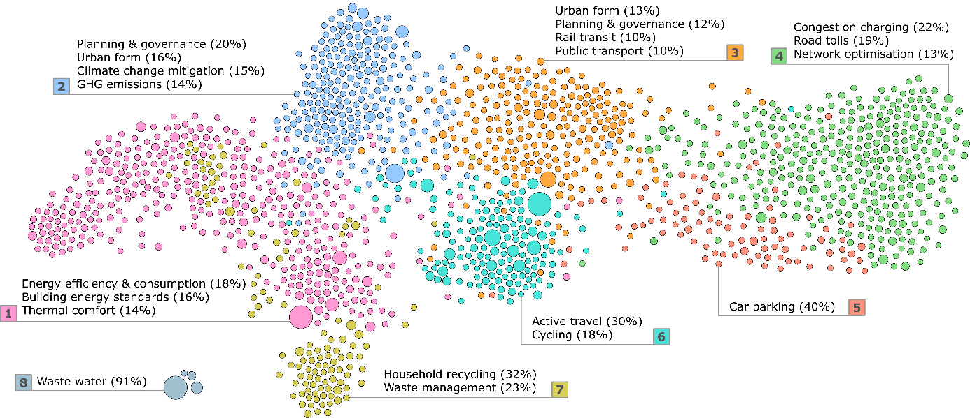

**Figure 4: Bibliographic coupling network of urban mitigation topics.** Each node (circle) represents a publication, scaled by total citations. Proximity between nodes indicates similar citing patterns. To identify epistemic communities, we specify clusters of proximate nodes using a community detection algorithm, then examine the topic proportions from the preceding analysis within each cluster. For instance, the publications that make up cluster 7 (coloured in yellow) are principally focused on household recycling and waste management (…).

Finally, and related to the timescale discussion (Figure 1), we perform a simple search on the document abstracts to identify years that are associated with projections or scenarios (extracting any 4 digit integers within the range 2020-2100). Where sufficient data is available, the average timescales ranged between 2020 and 2040, increasing to the upper end of this range for the topic cluster on urban form and planning and governance, and decreasing towards 2020 for waste management, building energy performance, and e-Vehicles. The sparse timescales beyond 2050 suggest little in the way of medium and long-term planning, even for topics related to fixed infrastructures.

**Discussion and conclusion**

It is the mandate of the IPCC to provide comprehensive, objective, open and transparent assessments of the available scientific literature on climate change [42]. We have argued elsewhere [17] that it will be increasingly challenging to fulfill this mandate in times of exponentially growing literature, unless there is real innovation in assessment practices. Experts selected by the IPCC themselves no longer have a comprehensive overview of the field – even as a group. In recognition of these new challenges, we delineate a literature corpus on urban climate change mitigation for the upcoming special report on the 1.5°C limit based on a transparent search query. This is a crucial precondition for any comprehensive scientific assessment, yet commonly neglected in practice. While there are many different ways in which this query could have been constructed, we aim to stimulate discussion on such fundamental questions and provide a basic resource to IPCC authors.

We find a total number of 8,210 publications growing annually at 20.5%. This is faster than the average expansion of the scientific enterprise as well as the climate change literature as a whole [17,43,44]. Our estimates do not reflect the entirety of the relevant literature for IPCC assessments due to our focus on: (1) energy demand and waste sectors alone; (2) a narrow interpretation of climate change mitigation that does not systematically consider wider sustainable development issues (Figure 2) that inevitably shape the mitigation solution space [45]; (3) the ISI Web of Science database, which only incompletely covers peer-reviewed and grey literature. Nevertheless, our sample is broadly representative in terms of the thematic structure of the available research.

We apply automated content analysis to digest the large amount of information in this corpus and map-out its topic landscape. Our results suggest that the mitigation focused literature is thus far mainly concerned with urban form and GHG emissions accounting. A wealth of policy-relevant research on transportation therefore risks being overlooked in climate change assessments. Principally this includes work on congestion and parking charges, but also to some extent active travel and public transportation provisioning. These literatures are based in distinct epistemic communities that tend to prioritize non-mitigation, sector-specific issues. By contrast, the buildings literature is already strongly aligned towards energy efficiency, via technical as well as behavioral interventions. Apparently the topic of urban climate change policies is just emerging, which is not surprising as there are still very few comparable emissions data available at the city scale [8,11] – particularly as large N samples [16,20,51–53].

Ideally, the mitigation literature would provide a platform for converging these multiple streams of work. Arguably, the embeddedness of building design and use within urban form and transportation systems has been largely overlooked so far. For instance, urban density, which enhances transportation efficiency and implies reduced floor space per capita, may pose a trade-off with building size, where increasing height becomes more costly in terms of materials and energy flows. In addition, public transit corridors, such as bus rapid transit, placed adjacent to new affordable housing developments provide residents with an accessible mobility option *before* they have purchased a personal vehicle, which has the potential to induce preferences and habits favoring public transportation that last for the medium to long term. This indicates important future directions of research that consider the additional mitigation benefits from integrated land-use and transport planning [47–50], instead of focusing on sector specific options only. Mitigating to 1.5 will require interaction and linkages across multiple urban dimensions – and this is especially true in places with rapidly growing cities.

We show that some topics have been better captured than others in AR5. While there might be very good reasons for those choices, we argue that systematic mappings of the literature landscape could help make assessment choices transparent and at the same time ensure that none of the major topics are neglected. We further note the availability of multiple reviews – a total of 372 in our literature corpus – that can be easily identified. In times when primary studies can no longer be comprehensively assessed within the IPCC, it seems absolutely key for the organization to explicitly prioritize the systematic assessment of these where available. We provide these reviews by topic, as well as the full document list, as a resource in the supplementary material.

Although there is yet to emerge a literature specific to cities and the 1.5°C target, this goal requires, fundamentally, a broadening of the policy space to harness all available mitigation options across governance scales. The challenge of the IPCC Special Report is therefore to examine a much wider array of literature than otherwise might be considered. Literatures that ought not to be overlooked are those that examine mitigation options in the building, transportation and waste sectors, and through urban form. Only a systematic and transparent approach will uncover their potential and pave the way for meaningful entry points into deep and lasting urban climate change mitigation.

1. Rogelj J, Luderer G, Pietzcker RC, Kriegler E, Schaeffer M, Krey V, Riahi K: **Energy system transformations for limiting end-of-century warming to below 1.5 °C** . *Nat. Clim. Chang.* 2015, **5**:519–527.

2. Luderer G, Pietzcker RC, Bertram C, Kriegler E, Meinshausen M, Edenhofer O: **Economic mitigation challenges: how further delay closes the door for achieving climate targets**. *Environ. Res. Lett.* 2013, **8**:34033.

3. Clarke L, Jiang K, Akimoto K, Babiker M, Blanford G, Fisher-Vanden K, Hourcade JC, Krey V, Kriegler E, Loschel A, et al.: **Assessing transformation pathways**. In *Climate Change 2014: Mitigation of Climate Change. Contribution of Working Group III to the Fifth Assessment Report of the Intergovernmental Panel on Climate Change*. Edited by Edenhofer O, Pichs-Madruga R, Sokona Y, Farahani E, Kadner S, Seyboth A, Adler A, Baum I, Brunner S, Eickemeier P, et al. Cambridge University Press; 2014.

4. IPCC: **Summary for Policymakers**. In *Climate Change 2014: Mitigation of Climate Change. Contribution of Working Group III to the Fifth Assessment Report of the Intergovernmental Panel on Climate Change*. Edited by Edenhofer O, Pichs-Madruga R, Sokona Y, Farahani E, Kadner S, Seyboth K, Adler A, Baum I, Brunner S, Eickemeier P, et al. Cambridge University Press; 2014:1–33.

5. Creutzig F, Agoston P, Minx JC, Canadell JG, Andrew RM, Quéré C Le, Peters GP, Sharifi A, Yamagata Y, Dhakal S: **Urban infrastructure choices structure climate solutions**. *Nat. Clim. Chang.* 2016, **6**:1054.

6. Müller DB, Liu G, Løvik AN, Modaresi R, Pauliuk S, Steinhoff FS, Brattebø H: **Carbon Emissions of Infrastructure Development**. *Environ. Sci. Technol.* 2013, doi:10.1021/es402618m.

7. Erickson P, Tempest K: *Keeping cities green: Avoiding carbon lock-in due to urban development*. 2015.

8. Karen C. S, Dhakal S, Bigio A, Blanco H, Delgado GC, Dewar D, Huang L, Inaba A, Kansal A, Lwasa S, et al.: **Human Settlements, Infrastructure, and Spatial Planning**. In *Climate Change 2014: Mitigation of Climate Change. Contribution of Working Group III to the Fifth Assessment Report of the Intergovernmental Panel on Climate Change*. . Cambridge University Press; 2014:923–1000.

9. Seto K, Dhakal S, Bigio AG, Blanco H, Delgado GC, Dewar D, Huang L, Inaba A, Kansal A, Lwasa S, et al.: **Chapter 12: Human Settlements, Infrastructure, and Spatial Planning**. *Clim. Chang. 2014 Mitig. Clim. Chang. Contrib. Work. Gr. III to Fifth Assess. Rep. Intergov. Panel Clim. Chang.* 2014.

10. Somanthan E, Sterner T, Sugiyama T, Chimanikire D, Dubash NK, Essandoh-Yeddu J, Fifita S, Goulder L, Jaffe A, Labandeira X, et al.: **National and Sub-national Policies and Institutions**. In *Climate Change 2014: Mitigation of Climate Change. Contribution of Working Group III to the Fifth Assessment Report of the Intergovernmental Panel on Climate Change*. Edited by Edenhofer O, Pichs-Madruga R, Sokona Y, Farahani E, Kadner S, Seyboth K, Adler A, Baum I, Brunner S, Eickemeier P, et al. Cambridge University Press; 2014:1141–1206.

11. Grubler A, Bai X, Buettner T, Dhakal S, Fisk D, Ichinose T, Keristead J, Sammer G, Satterthwaite D, Schulz N, et al.: **Urban Energy Systems**. In *Global Energy Assessment - Toward a Sustainable Future*. . International Institute for Applied Systems Analysis and Cambridge University Press; 2012:1307–1400. **[*First assessment on cities that attempts to gather global data on energy use, providing the ground for further structured investigations of urban climate drivers on global scale (ref 16,19).]**

12. IPCC: *Decision IPCC/XLIV-4. Sixth Assessment Report (AR6) Products, Outline of the Special Report on 1.5°C*. 2018.

13. Wilson C, Grubler A, Gallagher KS, Nemet GF: **Marginalization of end-use technologies in energy innovation for climate protection**. *Nat. Clim. Chang.* 2012, **2**:780–788.

14. Creutzig F: **Evolving Narratives of Low-Carbon Futures in Transportation**. *Transp. Rev.* 2016, **36**:341–360.

15. O’Neill BC, Dalton M, Fuchs R, Jiang L, Pachauri S, Zigova K: **Global demographic trends and future carbon emissions**. *Proc. Natl. Acad. Sci. U. S. A.* 2010, **107**:17521–6.

16. Creutzig F, Baiocchi G, Bierkandt R, Pichler P-P, Seto KC: **Global Typology of Urban Energy Use and Potentials for an Urbanization Mitigation Wedge**. *Proc. Natl. Acad. Sci.* 2015, **112**:6283–6288.

17. Minx JC, Callaghan MW, Lamb WF, Garard J, Edenhofer O: **Learning about climate change solutions in the IPCC and beyond**. *Environ. Sci. Policy* 2017, [in press]. **[** Points out that the ongoing literature explosion requires novel systematic tools for literature analysis in assessments.]**

18. Rosenzweig C, Solecki W, Romero-lankao P, Mehrotra S, Dhakal S, Bowman T, Ibrahim SA: *ARC3.2 Summary for City Leaders Climate Change and Cities: Second Assessment Report of the Urban Climate Change Research Network*. Columbia University; 2015.

19. Marcotullio PJ, Sarzynski A, Albrecht J, Schulz N, Garcia J: **The geography of global urban greenhouse gas emissions: an exploratory analysis**. *Clim. Change* 2013, doi:10.1007/s10584-013-0977-z.

20. Minx J, Baiocchi G, Wiedmann T, Barrett J, Creutzig F, Feng K, Förster M, Pichler P-P, Weisz H, Hubacek K: **Carbon footprints of cities and other human settlements in the UK**. *Environ. Res. Lett.* 2013, **8**:35039.

21. Gurney KR, Romero-Lankao P, Seto KC, Hutyra LR, Duren R, Kennedy C, Grimm NB, Ehleringer JR, Marcotullio P, Hughes S, et al.: **Climate change: Track urban emissions on a human scale**. *Nature* 2015, **525**:179–181.

22. Blei DM: **Probabilistic Topic Models**. *Commun. ACM* 2012, **55**:77–84.

23. Creutzig F, Fernandez B, Haberl H, Khosla R, Mulugetta Y, Seto KC: **Beyond Technology: Demand-Side Solutions to Climate Change Mitigation**. *Annu. Rev. Environ. Resour.* 2016, **41**. **[**Finds significant mitigation potential on the demand side, most of which to be realized on urban scale.]**

24. Mattauch L, Ridgway M, Creutzig F: **Happy or liberal? Making sense of behavior in transport policy design**. *Transp. Res. Part D Transp. Environ.* 2016, **45**:64–83.

25. Weinberger R, Goetzke F: **Unpacking preference: How previous experience affects auto ownership in the United States**. *Urban Stud.* 2010. **[*Reveals the importance of endogenous preferences in residential and transport choice.]**

26. Ewing R, Cervero R: **Travel and the Built Environment -- A Meta-Analysis**. *J. Am. Plan. Assoc.* 2010, **76**:265–294.

27. IEA: *Energy technology perspective - Towards sustainable urban energy systems*. 2016.

28. Grubler A, Fisk D: *Energizing Sustainable Cities: Assessing Urban Energy*. Routledge; 2013.

29. Salon D, Boarnet MG, Handy S, Spears S, Tal G: **How do local actions affect VMT? A critical review of the empirical evidence**. *Transp. Res. Part D Transp. Environ.* 2012, **17**:495–508.

30. Bongardt D, Breithaupt M, Creutzig F: **Beyond the fossil city: Towards low carbon transport and green growth**. In *5th regional environmentally sustainable transport forum in Asia, United Nations Centre for Regional Development, Bangkok, Thailand*. 2010. **[**Overview of policy options in urban transport.]**

31. Bongardt D, Creutzig F, Hüging H, Sakamoto K, Bakker S, Gota S, Böhler-Baedeker S: *Low-carbon land transport: policy handbook*. Routledge; 2013.

32. Ürge-Vorsatz D, Novikova A: **Potentials and costs of carbon dioxide mitigation in the world’s buildings**. *Energy Policy* 2008, **36**:642–661. **[*Breaks ground on systematically assessing the building sector's potential to climate mitigation.]**

33. Lucon O, Ürge-Vorsatz D, Zain Ahmed A, Akbari H, Bertoldi P, Cabeza LF, Eyre N, Gadgil A, Harvey LDD, Jiang Y, et al.: **Buildings**. In *Climate Change 2014: Mitigation of Climate Change. Contribution of Working Group III to the Fifth Assessment Report of the Intergovernmental Panel on Climate Change [Edenhofer, O., R. Pichs-Madruga, Y. Sokona, E. Farahani, S. Kadner, K. Seyboth, A. Adler,*. . 2014.

34. Ürge-Vorsatz D, et al.: **Energy End-Use: Buildings**. 2012, [no volume].

35. Cabeza LF, Urge-Vorsatz D, McNeil MA, Barreneche C, Serrano S: **Investigating greenhouse challenge from growing trends of electricity consumption through home appliances in buildings [Internet]**. *Renew. Sustain. Energy Rev.* 2014, **36**:188–193.

36. Bajželj B, Richards KS, Allwood JM, Smith P, Dennis JS, Curmi E, Gilligan CA: **Importance of food-demand management for climate mitigation**. *Nat. Clim. Chang.* 2014, **4**:924–929.

37. Lecocq F, Shalizi Z: **The economics of targeted mitigation in infrastructure**. *Clim. Policy* 2014, **14**:187–208.

38. Fujita M: *Urban Economic Theory*. Cambridge University Press; 1989.

39. Creutzig F: **How fuel prices determine public transport infrastructure, modal shares and urban form**. *Urban Clim.* 2014, **10**:63–76.

40. Lee DD, Seung HS: **Learning the parts of objects by non-negative matrix factorization. [Internet]**. *Nature* 1999, **401**:788–91.

41. Jacomy M, Venturini T, Heymann S, Bastian M: **ForceAtlas2, a continuous graph layout algorithm for handy network visualization designed for the Gephi software**. *PLoS One* 2014, **9**:1–12.

42. IPCC: **Appendix A: Procedures for the preparation, review, acceptance, adoption, approval and publication of IPCC Reports**. In *Principles Governing IPCC Work*. . IPCC; 2013.

43. Haunschild R, Bornmann L, Marx W: **Climate Change Research in View of Bibliometrics [Internet]**. *PLoS One* 2016, **11**:e0160393.

44. Grieneisen ML, Zhang M: **The current status of climate change research.** *Nat. Clim. Chang.* 2011, **1**:72–73.

45. von Stechow C, Minx JC, Riahi K, Jewell J, McCollum DL, Callaghan MW, Bertram C, Luderer G, Baiocchi G: **2oC and the SDGs: United they stand, divided they fall?** *Environ. Res. Lett.* 2016, **11**.

46. Sorrell S: **Reducing energy demand: A review of issues, challenges and approaches**. *Renew. Sustain. Energy Rev.* 2015, **47**:74–82.

47. Wegener M: **Overview of land use transport models**. In *Handbook of transport geography and spatial systems*. . Emerald Group Publishing Limited; 2004:127–146. **[**Transport land use models generate many detailed insights that are still insufficiently utilized in the climate mitigation literature.]**

48. Moeckel R, Nagel K: **Maintaining Mobility in Substantial Urban Growth Futures**. *Transp. Res. Procedia* 2016, **19**:70–80.

49. M. W: **Land-use transport interaction models**. In *Handbook of Regional Science*. . Springer; 2014:741–758.

50. Mitchell G, Hargreaves A, Namdeo A, Echenique M: **Land use, transport, and carbon futures: the impact of spatial form strategies in three UK urban regions**. *Environ. Plan. A* 2011, **43**:2143–2163.

51. Baiocchi G, Creutzig F, Minx J, Pichler PP: **A spatial typology of human settlements and their CO2 emissions in England**. *Glob. Environ. Chang.* 2015, **34**:13–21.

52. Markolf SA, Matthews HS, Azevedo IL, Hendrickson C: **An integrated approach for estimating greenhouse gas emissions from 100 U.S. metropolitan areas**. *Environ. Res. Lett.* 2017, **12**.

53. Minx JC: **Better data for assessing local climate policies**. *Environ. Res. Lett.* 2017, **12**.